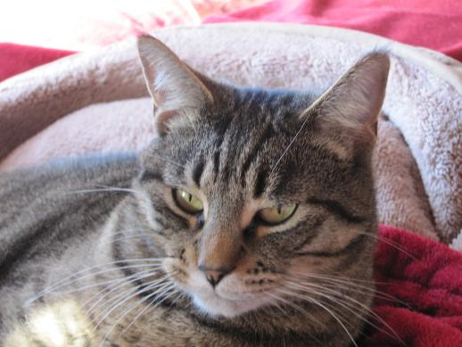
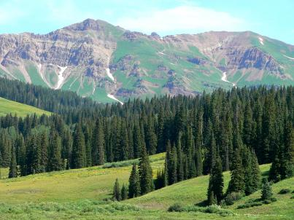
Rancho Europa, 2083 Lazy Z. Rd.
Nederland, CO 80466 USA
December 2009

Life has been so busy for us that we missed sending out holiday greetings last year. So these words and pictures look back on the two years since December 2007. We’re sending out hardcopy, but also posting this on our personal website, www.ranchoeuropa.com/xmas09.html.
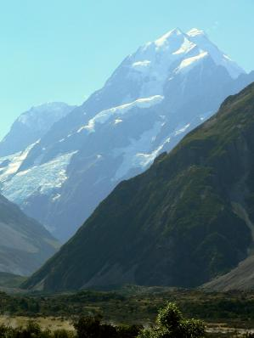
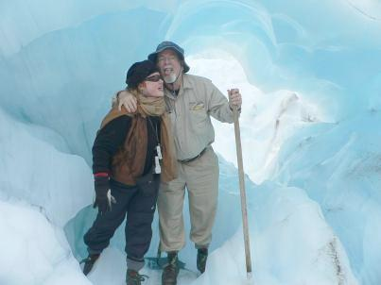
Amid Clark’s work and Y’s community activities, we’ve traveled a lot during 2008 and 2009, enduring the indignities of airports and airlines, but also touring Colorado by car. (The summer flowers in the mountains north of Crested Butte were stunning.) Our first big trip in 2008 was a week spent with friends Ted and Anne-Marie on the Big Island of Hawaii, where we toured the NASA Infrared Telescope Facility, which Clark and his colleagues often uses remotely from Boulder. Our next major excursion took us most of the way around the world to New Zealand. With friends Sam and Jan, we watched sunset, moonrise, and sunrise on Doubtful Sound and later were helicoptered onto Fox Glacier on our wedding anniversary.
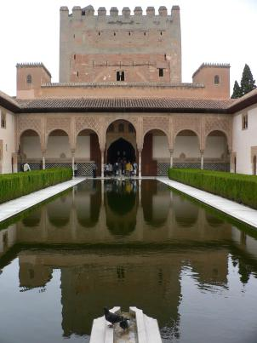
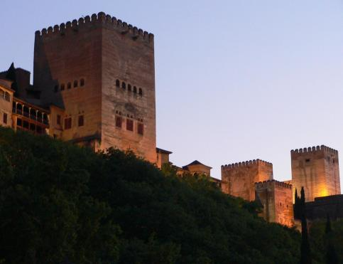
This spring we vacationed in Costa Rica, went to a planetary defense conference in Granada, Spain (and toured the Alhambra), traveled to another meeting in the splendid city of Nancy, France, and (for the first time ever) climbed up the catwalk to the “platform” of the Arecibo radar (the world’s largest, but threatened with closure), following the planetary science meeting in Puerto Rico. Y and Clark traveled to other conferences in Santa Barbara, Baltimore, Ithaca, Woods Hole, Flagstaff, Portland, and the Bay area. And we had the honor of paying our respects in California following the passing of treasured friend and colleague, Steve Ostro.
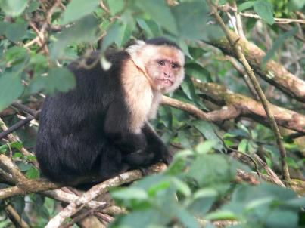
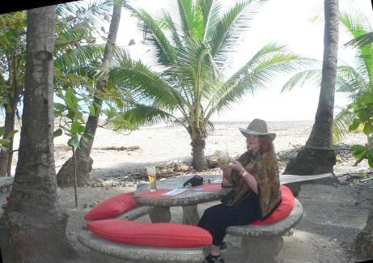
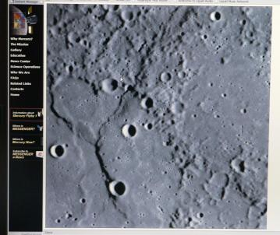
In spring 2008, we acquired (from the Humane Society) a new family member, Rocko, a young, tailless, manx feline. He’s an indoor manx, but fascinated by wildlife outdoors (or alternatively on the cat-sitter DVD). We continue to be visited by bears, coyotes, splendid bobcats, and herds of elk. Our neighborhood continues to evolve as old friends move away, others move in, and children grow. Music, in the form of folk music house concerts, has returned to the neighborhood, after a long and expensive battle with Boulder County. Our neighborhood’s future is now threatened by a planned tripling of capacity of Gross Reservoir down the road, to satisfy lawn-watering habits of Denverites.
A new building has sprouted south of the Southwest Research Institute offices in Boulder, but Clark can still glimpse the Flatirons from his window. The last two years have witnessed the MESSENGER spacecraft’s three flybys of Mercury, with surprising discoveries about extensive volcanism on that planet (it goes into orbit around Mercury in 2011). Clark is also part of NASA’s new Lunar Science Institute. And he spent much time in 2009 on the National Research Council’s forthcoming report to Congress on hazardous asteroids. Earlier this month, Clark appeared in a National Geographic special about the first-ever asteroid predicted to hit the Earth for sure: it struck in Sudan in October 2008, and Clark believes that future surveys can find and predict up to 50% of future impacts.
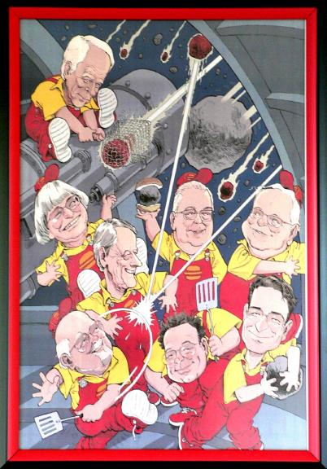
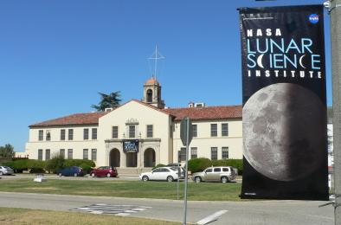
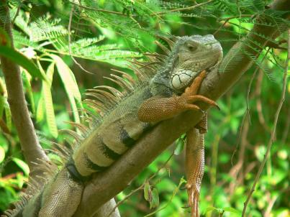
Y has kept busy with civic activities including Rotary, as well as improving Rancho Europa; last year she designed and built a new xeriscape by our entrance staircase. Ginette and Mitch moved from California and bought a house in west Denver; the Chapmans gathered for the first time in some years during niece Bonnie’s wedding near Syracuse. Mother/Mary is approaching her 97th birthday in North Carolina, trying to make it to 100.
We were encouraged that Obama was elected to fix the economic and international messes of the previous administration, but not so thrilled that the wars continue. As 2010 arrives we renew our hopes for peace in the world. And we wish you and yours good health and happiness in the second decade of the twenty-first century.

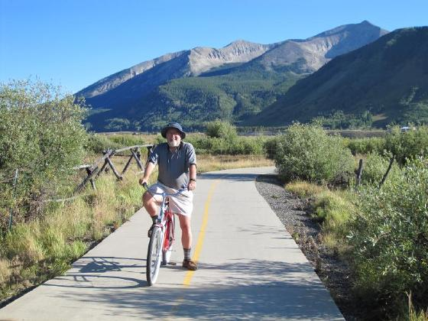
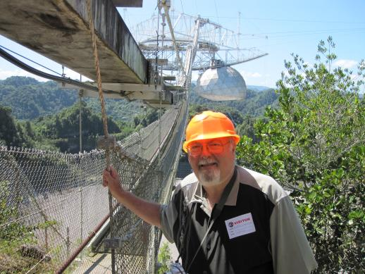
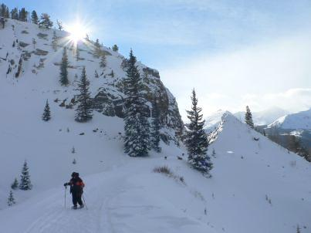
Clark, Y (lmc), and Rocko Chapman


